**2023 GR5260 Exam 1 Suggested solutions**

Q1. (a)

-1 if used t as days instead of years.

-1 if not consider t < df_times[0]

-1 if not consider t >= df_times[-1]

-2 if the interpolation part incorrect

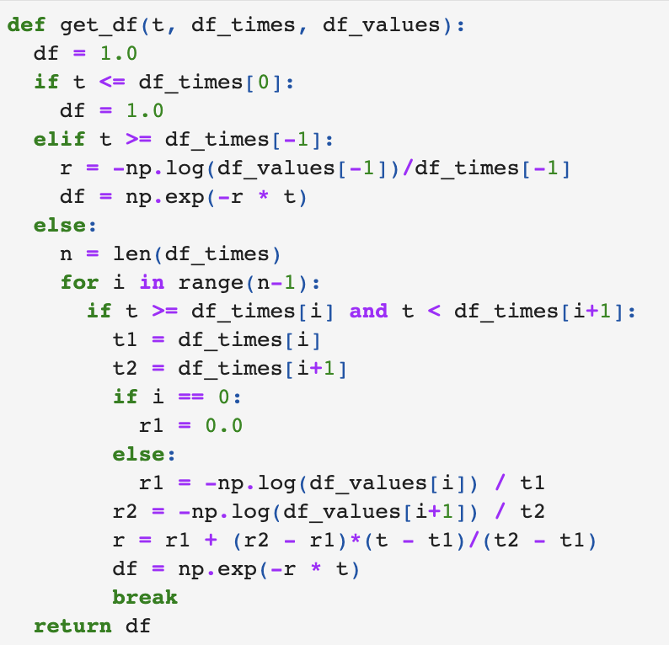

Q1. (b)

-4 if plot is completely incorrect due to plot code error or plot missing

-2 plot incorrect due to the problem from q1.a).

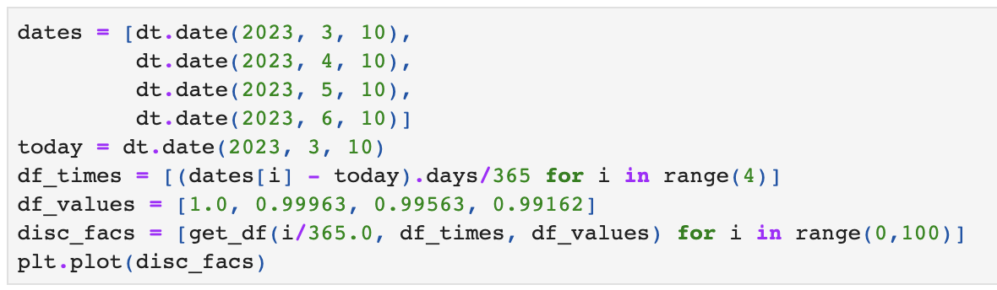

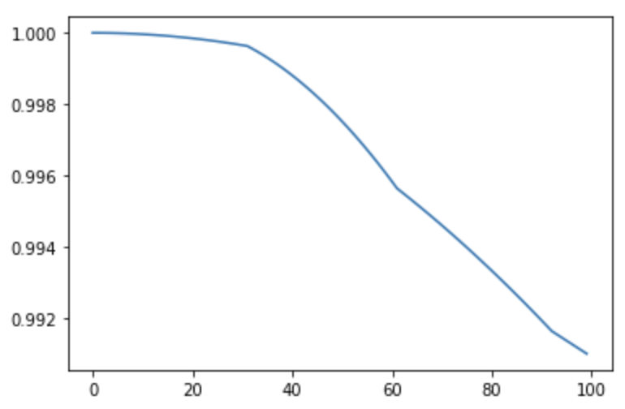

Q1. (c)

Q1. (d)

-1 if write out correct general formula but not specify for “daily” forward rate

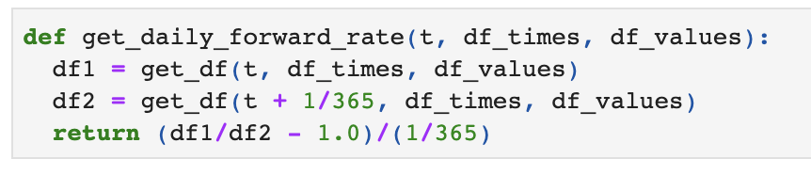

-4 if completely wrong in logic

Q1. (e)



-3 if plot is completely incorrect due to plot code error

-1 if print out correct discount factor but do not plot it

-2 plot incorrect due to the problem from q1.a) or q1.d).

-1 if do not annualize rates

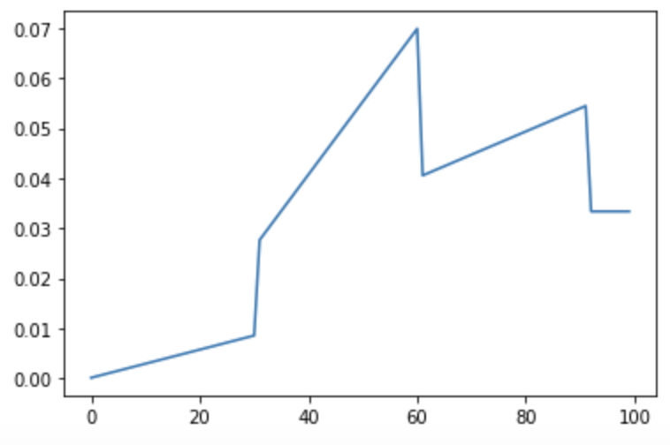

Q1. (f)

The daily forward rate curve is piecewise linear from 3/23/23 out to 3 months and then is flat beyond the 3M point.

-3 if not mention piecewise or similar description

-2 if not mention flat beyond 3M

Q2. (a)

-1 if one part of the formula is wrong

-4 if completely wrong

Q2. (b)

for i=1,2

-1 if not use Z1, Z2 as requested

Q2. (c)

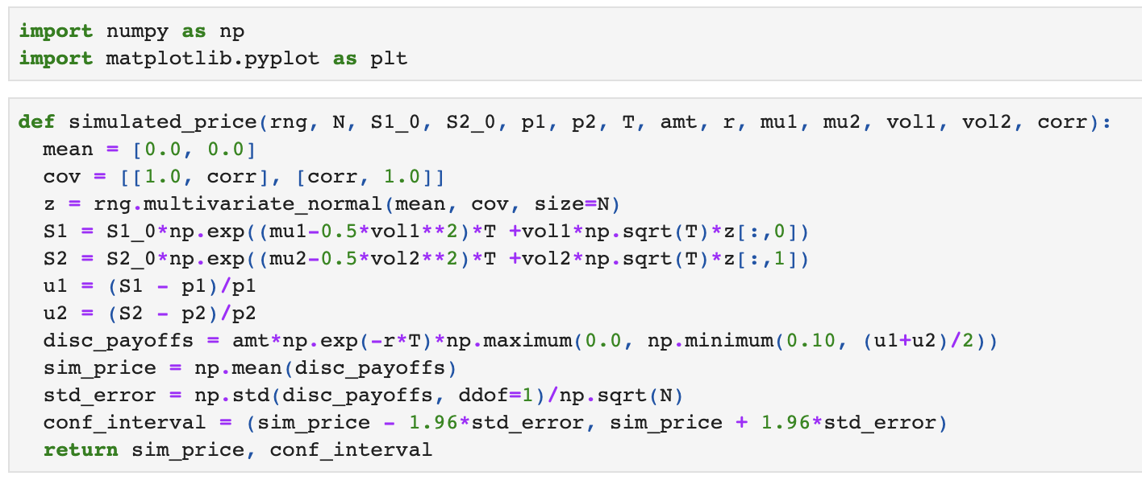

-1 if minor mistakes in code such as not discounting, missing AMT, etc

-2 if missing confidence interval

Q2. (d)

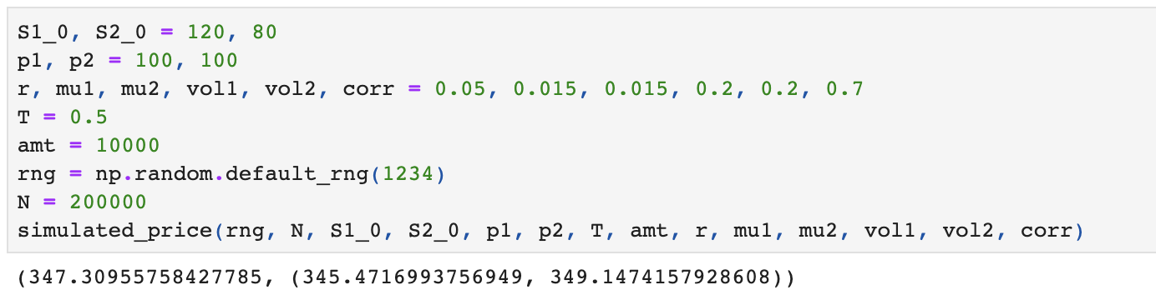

-1 if the number is wrong due to problems in previous questions

Q2. (e)

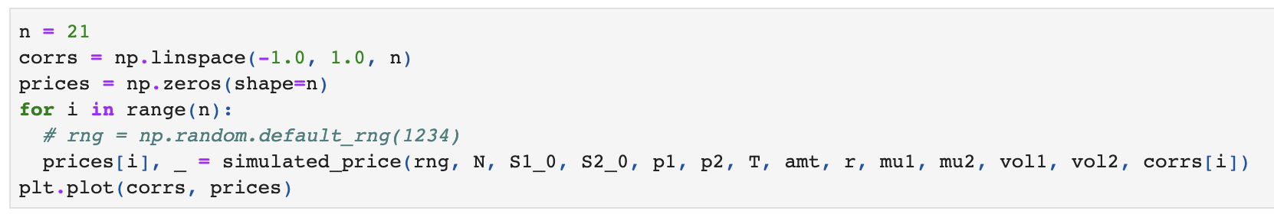

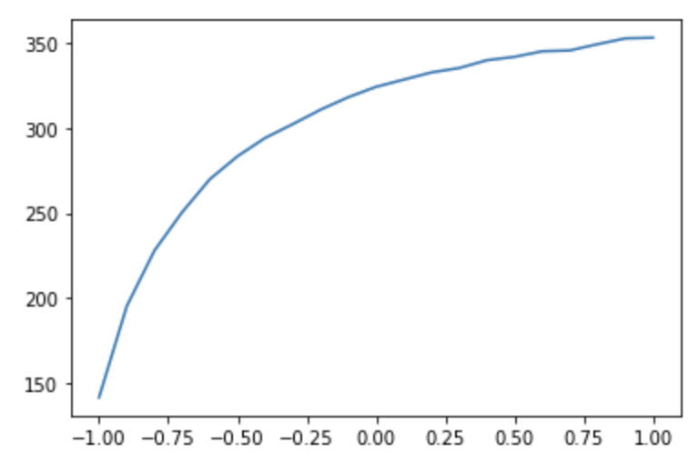

-3 if plot missing completely

-2 if plot is wrong due to plot code error

-1 if the plot is wrong due to problems in previous questions

Q3. (a)

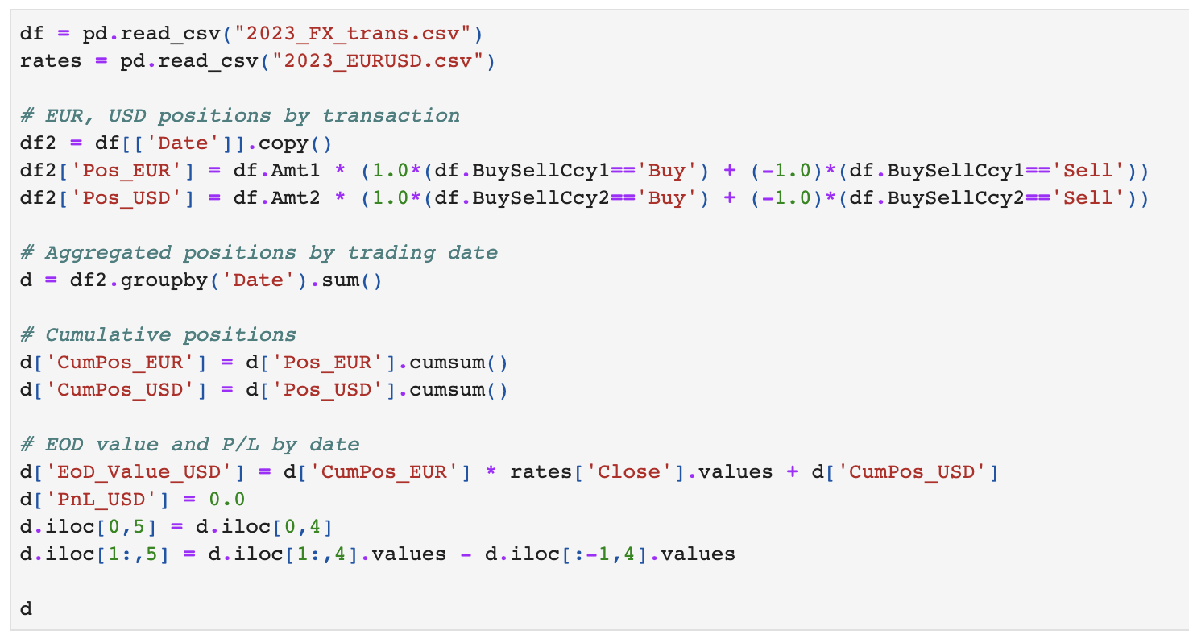

-3 if Post_EUR or/and Post_USD incorrect

-3 if CumPos_EUR or/and CumPost_USD incorrect

-2 if EoD incorrect

-2 if PnL incorrect

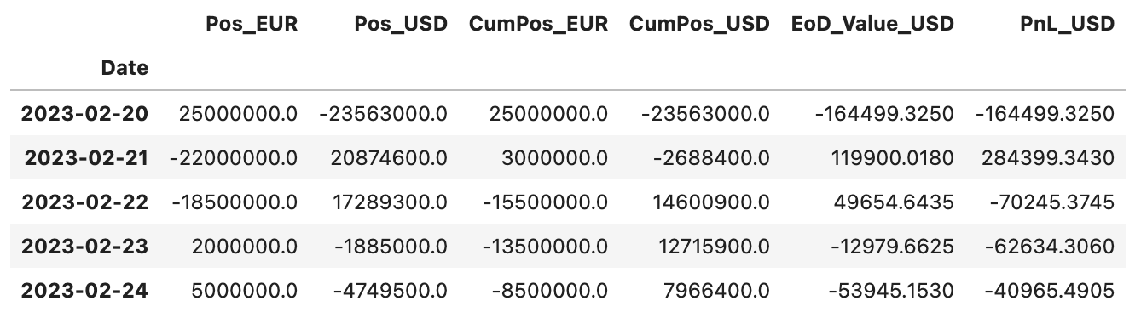

Q3. (b)

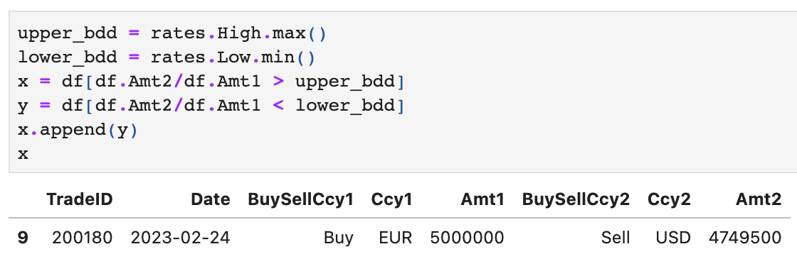

-3 if reasonably tried but incorrect logic

-2 if minor mistakes in code